LAB 3

Annotate the Domain classes to reflect the following Database Schema:

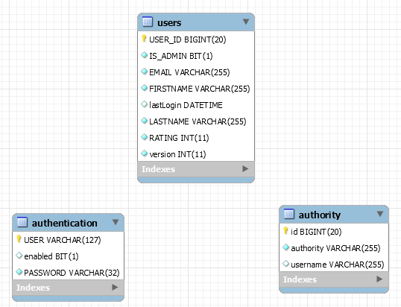

User.java

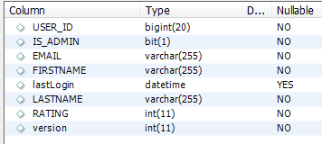

Authetication.java

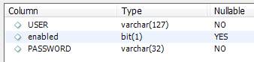

Authority.java

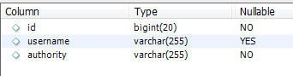

Also, complete the Main.java code to add a user & lookup the user by email and print the following:

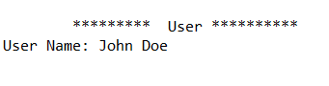

Furthermore, complete the UserDaoImpl.java to properly access the Generic Dao.

**ADDITIONAL:**

Exercise the Merge capability: Create an entity, Update entity; try updating the entity again with the “unmanaged” version of the entity. Expected result: StaleObjectStateException.

Exercise the Flush/Refresh capability.